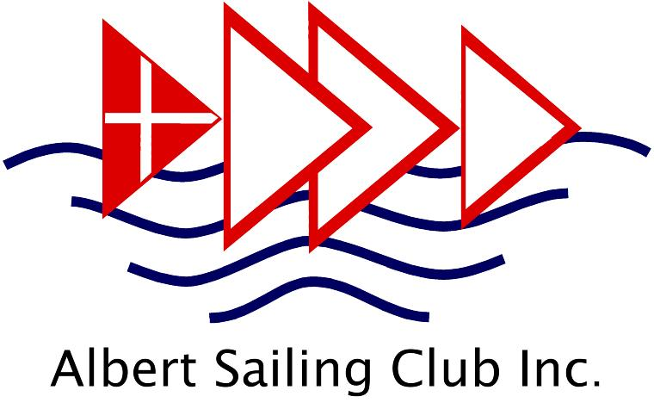
Albert Sailing Club
ABN: 47 825 037 530
1 Aquatic Drive
South Melbourne 3205

www.albertsc.org.au

{Insert the name and address/email of
your local MP here}

{Insert Date Here}

Dear {insert relevant title},

A number of sports such as Tennis, Golf and Lawn Bowls have received exemptions due to the unique nature of their sports; and their ability to satisfy government that they have procedures in place to minimise risks to participants and the community from COVID-19. In Victoria we have 90 affiliated clubs, who in turn have over 30,000 members. Across the state, we estimate that over 100,000 people participate in sailing annually.

Like the above-mentioned sports, Sailing has its own characteristics that we believe are worthy of consideration for being treated differently, rather than being captured by a one size fits all approach. These include:
- Sailing occurs in an environment that has exposure to more fresh air than possibly any other sporting activity
- Our “field of play” does not have rigid boundaries like an oval, field, track or pool.
  - Competitors in the same race can be separated by several hundred metres
  - A race involving 100 people could be dispesed over several square kilometres.
  - When racing offshore, this can extend to 100+ nautical miles.
- We are self-regulating. There are no “on-field” officials involved in a race unlike most sports. Race Committees operate from separate vessels, in small numbers.
- There are minimal spectators and no crowds- racing usually occurs far from land.
- Social gatherings at clubs are usually small as racing is staggered during a typical day
- There is no difference to the risk profile in Sailing whether conducting “training” or “competition”
Our challenges relate to the constraints that arise from sailing boats that need more than one person on board. These vessels require the crew to work together to perform manoeuvres, as well as being needed to provide ballast in order to counter the force of the wind so that the boat has forward motion. Specific issues include:
- Smaller multi crewed dinghies/ yachts need to operate in close proximity to each other
- Overnight/ offshore races have crew in confined spaces for long periods of time
- Larger yachts require crews greater than 10 people to sail them safely
- Rescue craft require more than one person on board in order to safely rescue sailors when required.

These are examples of typical sailing activities that would currently contravene state regulations.

In order to mitigate against the risks of COVID-19 and make them as low as reasonably possible, we have received detailed guidance notes from our peak body, Australian Sailing, so that our members can “Return to Sailing”. This includes sport- specific information relating to sailing equipment as well as the more general WorkSafe, Sport AUS other government advice, toolkits and templates.

We believe that the sport of sailing is a low risk activity and should be provided exemptions that will allow it to return our community to all facets of the sport- whether recreational, training or racing. The sailing community understands and endorses the social distancing and good hygiene measures. We will continue to promote and encourage their implementation for all onshore activities and facilities, in and around any club house venues. The exemptions we seek are purely limited to whilst participating in sporting activities and events. With this in mind, we have the following requests for exemptions:

- Competition be allowed

- Exemption from the 4m2 per person rule when participating in sailing activities Proposed solution:
Replace with “Comply with 4m2 per person where practically possible”

- Exemption from 1.5m rule when participating in sailing activities Proposed solution:
Replace with “Maintain 1.5m physical distance where practically possible”

- Exemption from the 10-person limit Proposed solution:
Permit sailing vessels to be manned with crew numbers to facilitate their safe operation

We recognise that the COVID-19 related restrictions and Public Health Orders are changing rapidly, however we request that the above exemptions are given due consideration.
This will enable us to provide clarity and certainty to our members and ensure that there are no unnecessary constraints inhibiting the community from participating in the sport of sailing.

Yours faithfully,
{Insert your name and address details}

