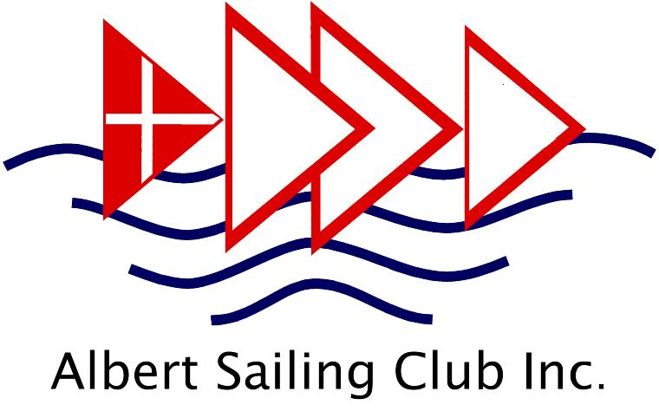 INCIDENT REPORT – GENERAL
(Use Child Safety Incident report for reporting abuse of juniors under 18yo)
To be completed by person(s) involved or witnessing a hazard or incident
The following information needs to be recorded and delivered to the Commodore within 24 hours of an incident on Albert Park Lake or Albert Sailing Club environs which involves an ASC member or asset
that results in an injury, damage to property, pollution, risk to safety, or identification of a hazard.
Attach additional sheets if insufficient room on this form.
Time & Date of incident:
Location:
Description of incident:
Details of damage or injury:
Names & contact details of people involved (including witnesses):
Actions taken:
People & organizations notified:
Has media been involved (Yes or No). If yes, give details:
Recommendations to avoid reoccurrence:

Name of Person completing this form: Date:
Signature: Time:
Name & Signature of Duty Race Officer:
Deliver in person or email to commodore@albertsc.org.au. V-27.11.22
INCIDENT REPORT
Instructions for completing & submitting an Incident Report
REPORTABLE INCIDENTS include:
Damage to any property for which Albert Sailing club is or may be responsible
Injuries to club members, to visitors or the general public which involve the property of Albert Sailing Club or its members.
Any identified hazards which may cause injury or damage in the future

NOTIFICATION OF AUTHORITIES
It is the responsibility of the Commodore or their designate to inform any relevant organisations or authorities of the incident.
Relevant authorities may include:
- Parks Victoria
- Victoria Police
- Yachting Victoria
- Insurance Companies
- Worksafe Victoria
- Sport Integrity Australia (For incidents that relate to Prohibited Conduct under the National Integrity Framework)
PERSONS RESPONSIBLE FOR COMPLETING an Incident Report
Any Albert Sailing Club duty crew member or club member witnessing a significant incident has a responsibility to ensure that an Incident Report is completed and submitted.
It is then the responsibility of Club Flag Officers or their delegate to follow-up on required actions.

DISCUSSION WITH MEDIA
The only person authorized to discuss an incident with the media on behalf of Albert Sailing Club is the Commodore of the Club or their nominated delegate.
SUBMITTING an Incident Report
Reports are to be promptly handed or forwarded to the Commodore at commodore@albertsc.org.au with a copy to the club Secretary at secretary@albertsc.org.au. The Commodore will then decide which committee member should review and take any necessary action on the report.
Albert Sailing Club telephone number: (03) 9690 2374

