ALLOCATIONS TO DIVISIONS BY CLASS AND YARDSTICK
Please see a member of the Race Management Team if your boat type has not been allocated a Division
DIVISION | FLAG | CLASSES
1 – ILCA 6  Y/Stick <119 | 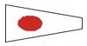 | ILCA 7 (Laser Standard)  ILCA 6 (Laser Radial)  Aero 5, 7, 9  Fireball  Tasar
2 - IMPULSE |  | Impulse
3 - SABRE  Y/Stick 120-127 | 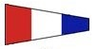 | Sabres  ILCA 4 (Laser 4.7)
4 – Mixed  Y/Stick 127.5 - 137 | 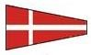 | Pacers  RS Zest  Jubilee  Miracle
5 – Mixed  Y/Stick 138 - 149 | 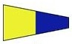 | Mirror  Heron  Salmo 15
6 - Mixed  Y/Stick >161 | 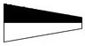 | Optimist  Minnow  Sabot
7 - SOLO | 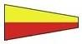 | Solo
8 – GREEN FLEET  Y/Stick - various | 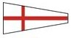 | Green Fleet  (Adult & Junior)
9 - MIXED  Y/Stick 150 - 160 |  | Open Skiff  Cadet

