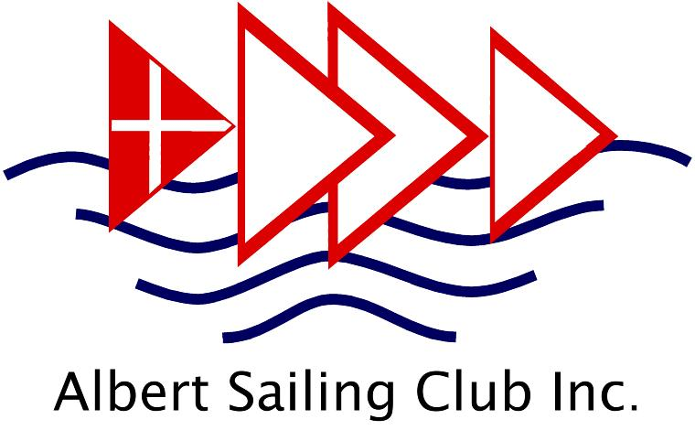

Albert Sailing Club ‘Top of the Lake’ Regatta

Saturday 20 and Sunday 21 June 2026

Albert Park Lake, South Melbourne

Organising Authority: Albert Sailing Club Inc

Notice of Race

RULES
- Races will be governed by the rules as defined in The Racing Rules of Sailing.
- Australian Sailing (AS) 2024 Special Regulations, Part 2 For Off the Beach Boats apply.
- Adequate covered footwear must be worn at all times and approved life jackets or buoyancy vests must be worn by all skippers and crew whilst afloat.
- Racing Rules will be changed as follows:
Rule 26: Starting Races (Timing)
Rule 27.1: Actions before the Starting Signal
Rule 29.2: General Recalls (Restarting)
Rule 32: Shortening Course
Rule 35: Time Limit
Rule 60.3 and 61.2: Protests and Redress
Rule 63.7: Reopening a Hearing
Rule A2: Scoring
Rule A4 & A5: Low Point System (Time Limits, Race Scores)
Changes will appear in full in the sailing instructions. The sailing instructions may also change other racing rules.

2. ELIGIBILITY
Racing is open to all monohull off-the-beach boats up to 5.5 metres in overall length.
The allocation of classes to divisions will be specified in the Sailing Instructions.
All competitors must hold a current Australian Sailing Registration Number

3. FEES
For Albert Sailing Club full year members the regatta entry fee is incorporated in member subscriptions.
For Albert Park Yacht Club Full year members the Saturday fee is waived. An entry fee is applicable for APYC full year members competing on the Sunday of the regatta as follows:
- APYC Adult Members: Sunday Fee: $30
- APYC Junior skipper: Sunday Fee: $25

Visitor Fees (including Albert Sailing Club and Albert Park Yacht Club Winter Season Associates)
- Adult skipper for full regatta : $50 online till Thursday 18 June. $60 for late entry.
- Junior skipper (under 18 years) for full regatta: $40 online till Thursday 18 June. $50 for late entry
- Adult - One Day : $30
- Junior skipper – One Day: $25
No entry fees apply for crews but crew members must hold a valid Australian Sailing number or obtain registration prior to the regatta.

4. ENTRY and SCHEDULE

Entries across all divisions will be capped at 80.

4.1 Entry Registration:

On-line through the Regatta Entry site until 10pm Thursday 18th June 2026 Here or via the ASC website Regatta page
Late entries will be accepted online until 8 p.m. on Friday 19th June and will include the relevant late entry fee. Credit Card or Paypal is preferred.

Further late Entries and Registration Updates will be accepted at the registration desk in the ASC clubhouse :

Saturday 20 June from 11am to 12.00pm.

Sunday 21 June from 9.00am to 10:00am for Sunday only entrants.

Late Entry payments must be made by Cash or Credit Card.
Where entry and payment is made on-line for a boat being sailed by adult(s) there is no need to attend the Regatta Registration desk upon arrival unless there is a change in entry details.
Where skipper and/or crew is under 18 years of age the Conditions of Entry Form available through the online Registration form must be acknowledged by a parent or legal guardian. For those being registered by a person other than parent or legal guardian or registering on the day, the form can be obtained via the regatta page on our website or will be available from the registration desk, It should then be signed by a parent or legal guardian and presented at the registration desk before the close of registration.
Competitors must indicate their intention to sail for each racing session by signing on as a starter on the Sign On sheets provided before each session in the Sign On/ Sign Off area behind the club foyer downstairs. Competitors must also Sign Off after each session of racing.
Competitors who are sailing in borrowed/hired boats on both days of the regatta must sail in the same boat (sail number and hull) on both days.
Additional Information for Junior Green Fleet entrants
Junior Green Fleet sailors need to nominate that they will participate as Green Fleet Sailors on the registration form. Green Fleet Sailors will race in a specific Green Fleet Division. The Organising Authority reserves the right to cancel racing for Junior Green Fleet sailors on any day of the regatta should wind and racing conditions be considered unsuitable for Junior Green Fleet sailors. If that occurs, a full refund for the cancelled days will be given to those registrants.

4.2 Schedule
The regatta will consist of a series of races of short course format across two sessions:
- Session 1: pm Saturday 20 June. Briefing session at approximately 12.30. First warning signal 1312 hrs. Subsequent races in the session will commence as soon as practical after all boats in a division/race have finished the race. ASC and APYC members should note that Races 1 and 2 of the session is also Autumn Championships 7 and 8.
- Session 2: Sunday 21 June. Briefing session at 09.45 a.m. only if required. First warning signal 10.27 hrs. Subsequent races in the session will commence as soon as practical after all boats in a division/race have finished the race. Racing may be postponed for a short lunch break depending on weather conditions and how many races have been completed.
No races will be started later than 15.00 on Sunday 21 June 2026.

5. MEASUREMENTS:
All boats need to comply with their class measurement rules. Any discrepancies shall be notified in writing to the Race Officer prior to the Information Session before the first racing session for which the discrepancies apply. Any allegations of measurement deficiencies shall be by means of a protest.
Only one set of sail and one hull shall be used during the regatta. These items may only be replaced after damage during this regatta and only after approval from race committee.

6. SAILING INSTRUCTIONS:
The Regatta Sailing Instructions shall be displayed on the Official Race Noticeboard. Copies will be available on the ASC internet website www.albertsc.org.au at least 4 days prior to the Regatta and from the Regatta Registration desk.

7. VENUE
Club racing takes place on Albert Park Lake, South Melbourne.

8. THE COURSES
Courses shall be provided in the Sailing Instructions and will consist of short course races in Albert Park Lake around a series of marks located in the Northern and Southern basins of the lake including the entrance to the ‘Narrows’. No racing will take place in the St Kilda Road basin. The specific courses to be sailed and the location of the marks will be determined by the Race Officer and will depend on the conditions on the day. See Appendix A to view the location of the course area.

9. SCORING

Results are compiled using the SailRes scoring system using Rule A5.2

Multiple races are scheduled at the Race Officer’s discretion, of which three (3) races are required to be completed to constitute a series.

When four (4) or less races are completed a boat’s series score shall be the total of all her race scores. This changes rule A2.

When five (5) or more races are completed each boat’s series score shall be the total of her race scores excluding her worst score.

10. SUPPORT BOATS
Support boats other than club patrol boats, are restricted due to the confined nature of the sailing course areas. Use of any support boats is at the discretion of the Race Officer and requires Race Officer approval before the warning signal for a Session. Support boats shall comply with Parks Victoria regulations on use of power craft on Albert Park Lake.

11. PRIZES:
- Trophies for classes of boat will be awarded based on the average number of entrants per race across all sessions in the regatta.
Average Number of Class Entrants per Race | Trophies Awarded
Less than three (<3) | None
Three to five (3-5) | First Place on Line honours
Six to Nine (6-9) | First and second place on Line Honours
Ten or more (>10) | First, Second and Third place on Line Honours
Additional Trophies may be given at the discretion of the Race Committee

Junior and Senior Regatta Championship trophies will also be presented based on yardstick results adjusted for laps sailed.

12. DISCLAIMER OF LIABILITY
Competitors participate in the regatta entirely at their own risk. See Rule 4. Decision to Race. The organizing authority will not accept any liability for material damage or personal injury or death sustained in conjunction with or prior to, during or after the regatta.

13. INSURANCE
Each participating boat shall be insured with valid third-party liability insurance with a minimum cover of AUD$10,000,000.

14. FURTHER INFORMATION
Albert Sailing club website Regatta page or email Jaemie/Rod via sailing @albertsc.org.au
CANTEEN:
The canteen upstairs in the clubhouse will operate over the lunch period on Saturday and lunches should be pre-ordered and paid for upon arrival at the club to guarantee availability. Participants will need to provide their own lunch on Sunday noting that the lunch break may be relatively brief to allow racing to recommence as soon as possible. A café is located a short distance from the Clubhouse.
A barbecue will be available on the club balcony after sailing on Saturday and hot nibbles will be provided after sailing on Sunday.
BOAT STORAGE:
Some overnight boat storage on the Saturday night will be available in the Albert Sailing Club boat yard. Please indicate on the Regatta Entry Form if you are seeking overnight storage. Announcements regarding when storage can commence will be made after the conclusion of Session 1 on the Saturday. Owner risk applies.

APPENDIX A
RACE AREA
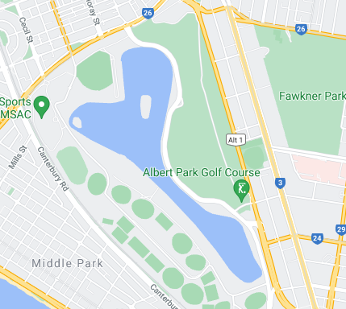
Location of Albert Sailing Club

Northern Basin

Southern Basin

The ‘Narrows’

St Kilda Basin (no
racing in this area)

