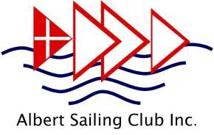
Albert Sailing Club ‘Top of the Lake’ Regatta
Saturday 20 and Sunday 21 June 2026
Albert Park Lake, South Melbourne
Organising Authority: Albert Sailing Club Inc
Supplementary Sailing Instructions

1. Rules
Races will be governed by the rules as defined in The Racing Rules of Sailing (RRS) 2025-2028.

2. Notices to Competitors
Notices to competitors will be posted on the official Race Notice Board located behind the club foyer (downstairs), immediately above the bench for the sign on/ sign off sheets. Course Boards will be posted at Information Sessions held immediately in front of the clubrooms or in the upstairs area of the clubhouse.

3. Changes to Sailing Instructions
Any change to the Sailing Instructions will be posted at least 1 hour prior to the start of the session affected thereby.

4. Signals Made Ashore
Signals made ashore will be displayed on or near the club flagpole located near Race Headquarters.
- When flag AP is displayed ashore, ‘1 minute’ is replaced with ‘not less than ten minutes’ in the race signal AP. This changes Race Signal “AP”.

5. Schedule of Races
A minimum of three races must be held to constitute a series.
Multiple Races will be scheduled across two sessions:
- Session 1: The afternoon of Saturday 20 June. Information session at 12.30 p.m. Scheduled time for the first warning signal is 13.12 p.m. Subsequent races in the session will commence as soon as practical after all boats in a division have finished the race.
- Session 2: Sunday 21 June. Information session (if held) will be at 9.45 a.m. Scheduled time for the first warning signal is 10.27 a.m. Subsequent races in the session will commence as soon as practical after all boats in a division have finished the race. Racing may be postponed for a short lunch break depending on weather conditions and how many races have been completed.
- In the session on Sunday 21 June, no warning signal will be made after 14:57 p.m.
The target wind speed range for a start or race is between 3 and 22 knots. If the wind speed average across the course over 10 minutes is consistently exceeding 22 knots or is consistently less than 3 knots, the start or race may be either postponed or abandoned at the discretion of the Race Officer.
The Organising Authority reserves the right to cancel racing for Junior Green Fleet sailors on any day of the regatta should wind and racing conditions be considered unsuitable for Junior Green Fleet sailors. If that occurs, a full refund for the cancelled days will be given to those registrants.

6. The Courses
Sample courses are illustrated in the Appendix to these sailing instructions. These are indicative courses only.
At the discretion of the race officer, each course may include Inner (I) and Outer (O) Marks, with the inner course to be sailed by junior divisions.
The direction for rounding buoys is defined by the display of a red or green flag on the start boat. This flag is displayed before the warning signal for the first division start. A red flag indicates buoys are to be rounded on the port hand and a green flag indicates the buoys are to be rounded on the starboard hand.
Divisional flags will be numeral pennants. The allocation of classes to Divisions will be posted on the regatta website no later than 5 p.m. on Friday 19 June and will be displayed on the official Race Notice Board.
The specific course(s) for the session, whether the Division is sailing the Outer or Inner marks and the location of the finish line will be posted on the Course Board in the briefing area at least 30 minutes before the first warning signal for each session. The island may have a required side; this will be defined on the course board at briefing prior to a session.
The number of laps for each division is shown on the course board located on the starboard side of the Start boat. If the number of laps is varied for the next race of the session, four short hoots will be sounded on the Start Boat shortly before the warning signal for the first race for that session. Sailors should then check the course board to see the revised number of laps.

7. Marks
Mark locations will be as shown on the course board in the briefing area. Gunn Island is not a mark of the course. Marks for the outer course will be yellow stick flags. If a separate Junior/Green fleet course is set, Marks A and B for the Junior/Green Fleet course will be blue stick flags. Mark C for the Junior/Green Fleet course may be either a blue flag or the outer course yellow flag and will be advised at the briefing session.

8. The Start
The Race Committee vessel shall display, together with three short hoots, an orange flag five minutes before the warning signal for the first race in each session. This flag and the audible sound are to alert boats that the sequence of races will begin soon.
8.1 Divisions will be started at 3 minute intervals as follows; this changes RRS 26.
Minutes before start signal | Signal | Description
3 | Warning | Division flag(s) displayed with one sound
2 | Preparatory | Preparatory flag displayed (P, U, Black, etc)
1 | One minute | Preparatory flag removed
0 | Start | Division flag(s) removed with one sound
The start signal for a division may be the warning signal for the next scheduled division.
8.2 The starting line will be between the mast displaying the orange flag on the Race Committee Boat and the course side of the port-end starting mark which is a blue and yellow striped stick flag.
8.3 A boat that does not start within six minutes after her starting signal will be scored “Did Not Start” (DNS) without a hearing. This changes RRS A4 and A5.
8.4 After the first warning signal, boats whose warning signal has not been given shall keep clear of the start line.

9. General Recalls (This changes RRS 29.2)
When a general recall is signalled, that division shall be restarted after all scheduled starts have been completed.
Thus the starting signal for the last scheduled Division shall be the Warning Signal for the first recalled Division; the starting Signal for the first recalled Division shall be the Warning signal for the second recalled Division, etc.

10. Shortening Course (This changes RRS 32)
Shortening course will be as in Rule 32 or when a race management boat displays flag “S” together with flag “H” at or near a rounding mark. If flag “S” together with flag “H” has been displayed, boats shall pass the rounding mark on the required side then proceed to the finish line.

11. The Finish
11.1 The specific location of the finish line is dependent on wind direction and will be specified at the information session. The line will be one of the following:
- Common Start/Finish boat: a mast or staff displaying a blue flag on the Race Committee boat and the finishing mark, which shall be a red stick flag. If the blue flag is on display on the Race Committee boat, the finish line must not be crossed by a boat unless it is finishing, and may be penalised by the Race Committee if it so crosses.
- Clubhouse Finish: a mast or staff displaying the club burgee and a blue flag on the clubhouse tower and the finishing mark, which shall be a red stick flag.
If a boat crosses the finish line multiple times, the latest of these times will be recorded as the boat’s finishing time. This amends the definition of ‘Finish’ in the RRS.
11.2 Further races will be conducted in the relevant session unless the Race Committee boat is flying flags as follows:
- Flag L: (yellow and black squares): No more racing today. This will be used at the conclusion of the Saturday afternoon session and the conclusion of racing on Sunday.
- AP over H: races not started are postponed. Further signals ashore. This will also be used if racing is to be postponed on the Sunday for a short lunch break.
11.3 At the direction of the Race Officer, any race management boat may finish a boat within a fleet at or near a mark to enable a subsequent race to start. The Race Officer may not finish a boat in accordance with this clause sooner than five minutes after the first boat in their division finishes. A boat so finished will receive points equal to the position occupied at the time the boat was finished. This changes the RRS definition of finish and rules 35, A4 and A5.

12. Time Limits
The time limit for each division in each race shall be one (1) hour. Boats failing to finish within fifteen minutes after the first boat in their division sails the course and finishes, or after the time limit, whichever is later, will be scored Did Not Finish without a hearing. This changes rules 35, A4 and A5.

13. Protests and Requests for Redress
13.1 Protests and requests for redress may be made on forms available from Race Headquarters located in the ASC control tower at the front of the upstairs clubrooms and lodged with the Race Committee within forty minutes of the finish time of the last boat in her division to finish in the last race of the session in which the incident occurred. This changes RRS 60.3.
13.2 Notices will be posted no later than 30 minutes after the protest time limit to inform competitors of the time and place of hearings in which they are parties or named as witnesses.
13.3 On the last scheduled day of racing a request for re-opening a hearing shall be delivered:
- a) Within the protest time limit if the requesting party was informed of the decision on the previous day:
- b) No later than 30 minutes after the requesting party was informed of the decision on that day.

14. Scoring
14.1 Multiple races are scheduled at the Race Officer’s discretion, of which three (3) races are required to be completed to constitute a series.
- Results are compiled using the SailRes scoring system.
- When four (4) or less races are completed a boat’s series score shall be the total of all her race scores. This changes rule A2.
- When five (5) or more races are completed each boat’s series score shall be the total of her race scores excluding her worst score.
14.2 Boats must compete in at least half the races in the series to qualify for a series score and to have signed on for at least one race on each day of the regatta (unless a day’s racing is abandoned or postponed) to be eligible for a trophy.

15. Safety Regulations [DP]
15.1 It is a club safety requirement that all crew wear adequate footwear and that approved Life Jackets or buoyancy vests are worn by all skippers and crew whilst afloat.
15.2 Sign On
Boats shall indicate their intention to compete in a session by completing the Sign On sheet for that session located on the bench immediately behind the club foyer below the official Race Notice Board.
15.3 Sign Off
Boats shall sign off by signing the Sign Off sheet for each session provided below the official Race Notice Board within thirty minutes of the last boat to finish the final race of a session. Boats failing to sign off within the prescribed time may be disqualified without a hearing. This changes RRS 35, A4 and A5.
15.4 Boats retiring are requested to advise the Race Committee boat or a Rescue boat on the water if possible, and to Sign Off as soon as possible upon returning to shore.

16. Disclaimer of Liability
Competitors participate in ASC racing entirely at their own risk. Attention is drawn to Fundamental Rule 3. Decision to Race “The responsibility for a boat’s decision to participate in a race or to continue to race is hers alone.” The Albert Sailing Club will not accept any liability for material damage or personal injury or death sustained in conjunction with or prior to, during or after ASC sailing events.

APPENDIX A
Courses will consist of short races in Albert Park Lake around a series of marks located in the Northern and Southern basins of the lake including the entrance to the ‘Narrows’. No racing will take place in the St Kilda Road basin.
There may be inner and outer courses.
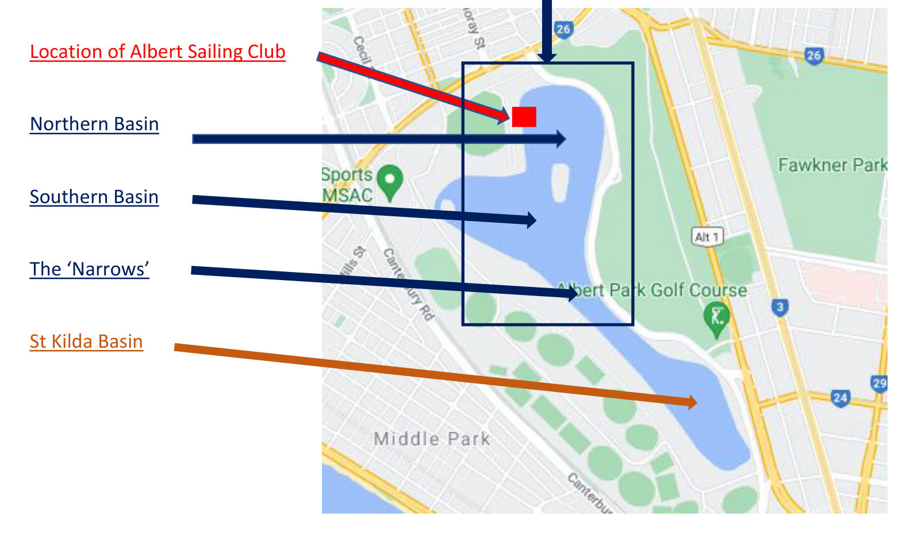
Sample Course Diagrams are set out below

All Courses will be Triangular
The specific location of the start boat and finish line is dependent on wind direction and will be specified at the briefing session.
Left — Starboard course: Southern Basin Start, Common Start/Finish boat
Right — Port course: Southern Basin Start, Common Start/Finish Boat
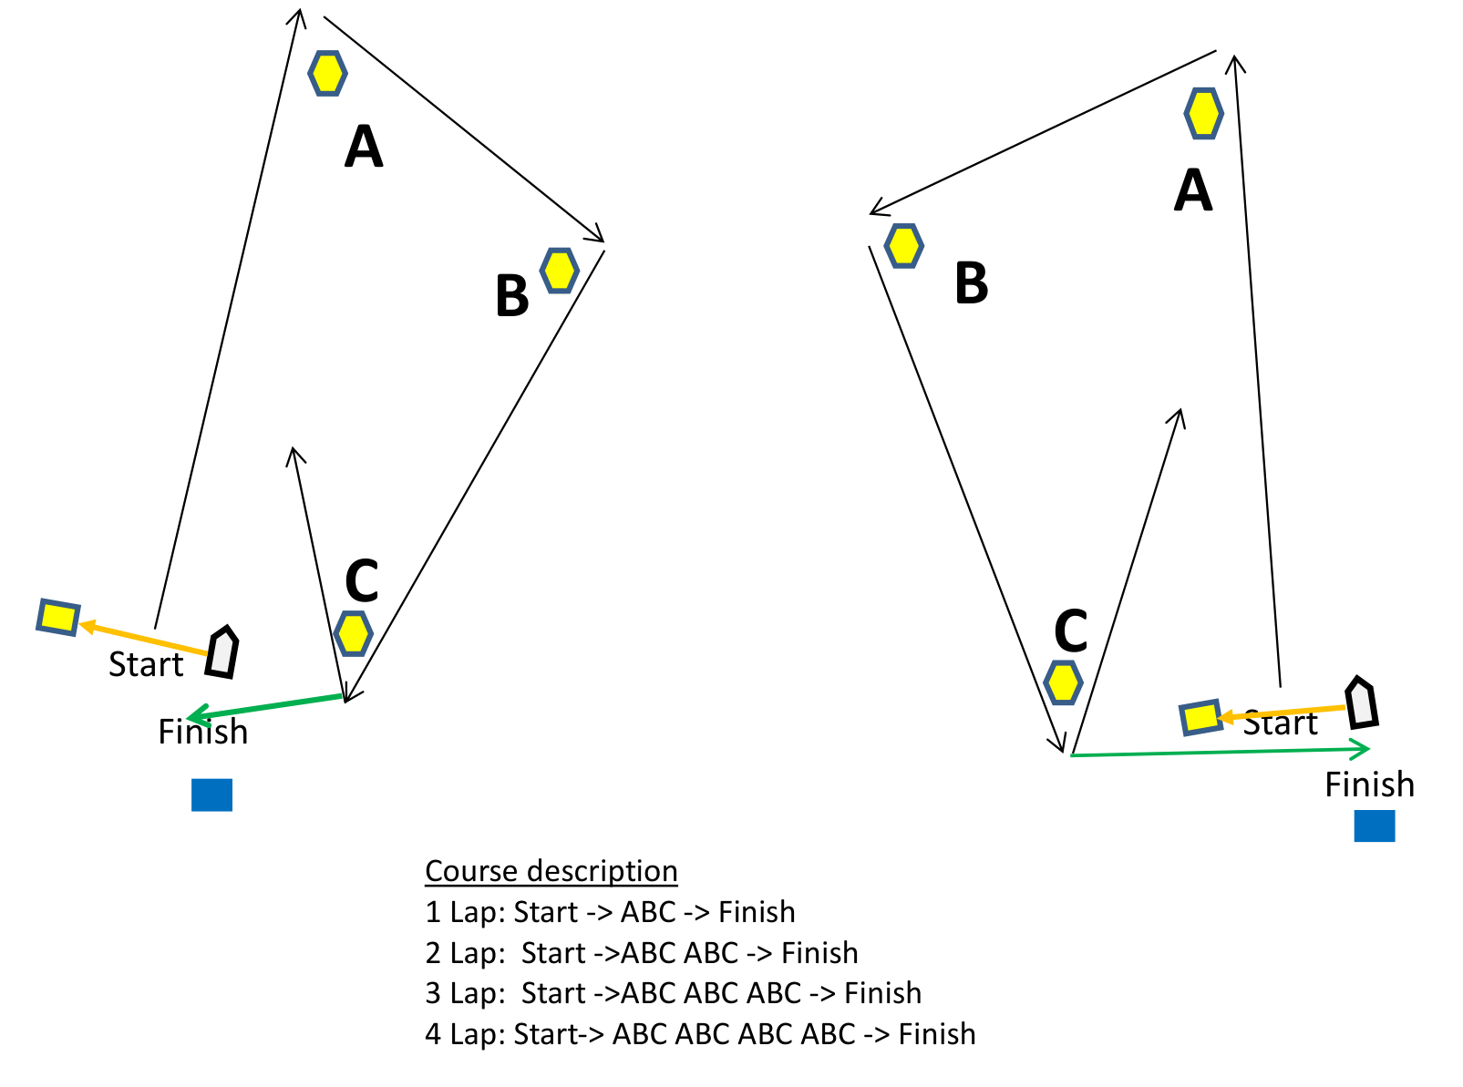

Left — Starboard course: Northern Basin Start, Clubhouse finish
Right — Port course: Northern Basin Start, Clubhouse finish
