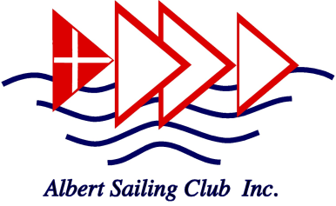
Child Safety Code of Conduct

All Albert Sailing Club (ASC) members, Committee members, Instructors, Associates, volunteers and family members of ASC members and associates are required to observe child safety principles and expectations for appropriate behaviour towards and in the company of children, as noted below.

All personnel of Albert Sailing Club are responsible for supporting the safety, participation, wellbeing and empowerment of children by:
- upholding Albert Sailing Club statement of commitment to child safety at all times
- taking all reasonable steps to protect children from abuse
- treating everyone with respect
- listening and responding to the views and concerns of children, particularly if they are telling you that they or another child has been abused and/or are worried about their safety or the safety of another
- promoting the cultural safety, participation and empowerment of Aboriginal children (for example, by never questioning an Aboriginal child’s self-identification)
- promoting the cultural safety, participation and empowerment of children with culturally and/or linguistically diverse backgrounds (for example, by having a zero tolerance to discrimination)
- promoting the safety, participation and empowerment of children with a disability (for example, during personal care activities)
- ensuring as far as practicable that adults are not left alone with a child
- reporting any allegations of child abuse to Albert Sailing Child Safety Officers*, or Albert Sailing Club Flag Officers, and ensure any allegation is reported to the police or child protection
- reporting any child safety concerns to Albert Sailing Child Safety Officers*, or Albert Sailing Club Flag Officers
- if an allegation of child abuse is made, ensure as quickly as possible that the child(ren) are safe
- encouraging children to ‘have a say’ and participate in all relevant organisational activities where possible, especially on issues that are important to them.
Members and volunteers must not:
- develop any ‘special’ relationships with children that could be seen as favouritism (for example, the offering of gifts or special treatment for specific children)
- exhibit behaviours with children which may be construed as unnecessarily physical (for example inappropriate sitting on laps. Sitting on laps could be appropriate sometime, for example while reading a storybook to a small child in an open plan area)
- put children at risk of abuse (for example, by locking doors)
- do things of a personal nature that a child can do for themselves, such as toileting or changing clothes
- engage in open discussions of a mature or adult nature in the presence of children (for example, personal social activities)
- use inappropriate language in the presence of children
- express personal views on cultures, race or sexuality in the presence of children
- discriminate against any child, including because of culture, race, ethnicity or disability
- have any inappropriate online contact of a personal nature with a child or their family.
- ignore or disregard any suspected or disclosed child abuse.
By observing these standards you acknowledge your responsibility to immediately report any breach of this code to Albert Sailing Club Child Safety Officers* or an Albert Sailing Club Flag Officer.
If you believe a child is at immediate risk of abuse please phone 000.
*ASC Child Safety Offficers 2017/18 – Jaemie Wilson and Edwige Kozinski

